Supporting the work of the Gospel in the Gambia
http://www.thegambiapartnership.co.uk info@thegambiapartnership.co.uk
Dear friends, supporters and encouragers,
Greetings in the name of our Lord and saviour Jesus Christ from The Smiling coast of West Africa.
“If Jesus Christ be God and died for me, then no sacrifice can be too great”. These daring words came from C.T Studd when he forsook a life of affluence and pleasure for total abandonment for Christ in missions. Indeed in light of what God in Christ did for us, giving up our comfort, money and time to let others know of his way of salvation for hell deserving sinners is the least we can do in appreciation of such a Great salvation. John Calvin once asked: “When we know God to be our Father, should we not desire that he be known as such by all? And if we do not have this passion, that all creatures do him homage, is it not a sign that his glory means little to us?”. Of course, the Gambia Partnership desires such so we’ve been on the road sharing the bad news of man’s sin and his inability to save himself from divine wrath through judgment alongside the Good news of salvation through faith in Christ’s atoning work on the cross which alone can save.
I am always indebted to all the brothers and sisters praying for the work in the Gambia as this is indeed a spiritual work and I am but a means that the spirit of God uses to save His people. It has been said that “The man or woman at home who prays often has as much to do with the effectiveness of the missionary on the field, and consequently with the results of his or her labours, as the missionary”.
October was a busy month for me and God made much of my travels within the Gambia successful. I was in a village called Darsilami where many who professed to be Christians are turning away from the faith and embracing Islam. I was much concerned so I went there alongside a true brother in the faith who is also a mission worker. We went to the house of a young lady who used to sing at the local Roman Catholic Church but who had left turning down all appeals not to do so. She happily received us in her home. We became friends in a quick time and laughed about many things but we knew we are to speak to her about her soul. She boldly told us she was a Muslim although she has never read the Quran. My colleague who also came from a Fula Muslim background used his past and his discovery of salvation to talk to her about the condition of her soul. We both engaged her to see Jesus as not just an option one can choose or not choose but as the only way of salvation. I quoted from the Quran severally to make a case that the Isa (Jesus) of the Quran cannot save and told her to come back to the Jesus Christ of the Torah and Injeel (Gospels) which the Quran affirms has guidance and light by which we must judge (cf.Sura 5:43-47,50,70,72 etc). Muslims are quick to say we also believe in Jesus so I try to let them know it’s not just any Jesus but only the Jesus of The Holy Bible can save who is ‘Son of God, begotten of his Father before all worlds, God of God, Light of Light, very God of very God, begotten not made, being of one substance with the Father’ (Nicene creed) . Being someone who believes in Scripture alone, any reference to an uninspired book in missions is to point out the error and explain the truth as taught in Scripture.
Sister Jennifer was very happy to hear the good news of Christ clearly explained. Remember her in your prayers that she will not just stop at being happy about the Good news but will come to believe and trust in Christ alone though the work of God’s Spirit that accompanies faithful proclamation. She introduced us to her entire family and her uncle who is now a retired teacher was very happy when we told him our mission. He asked us to be coming every Lord’s Day to preach the Gospel to his household and all whom they can invite. After responding to his question about who Jesus is, he went so far as telling me that he would like to tell the Roman Catholic priest to grant us access to teach the Good news to their people. We’ve been going there every Sunday and we trust that our teaching will be used of God to bring them to faith in Jesus Christ as revealed in Scripture. Jennifer’s mum is the prophetess at the village shrine called ‘Jalang’ where sacrifices are being offered even on Sundays. Pray that they will all come to know Jesus Christ whom can save. Also pray that God protects the missionary as I take the Good news to spiritually polluted areas for the glory of God.
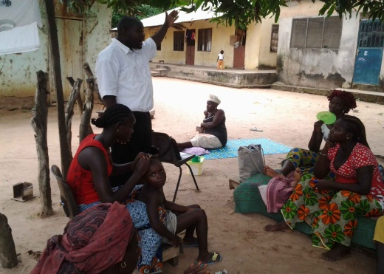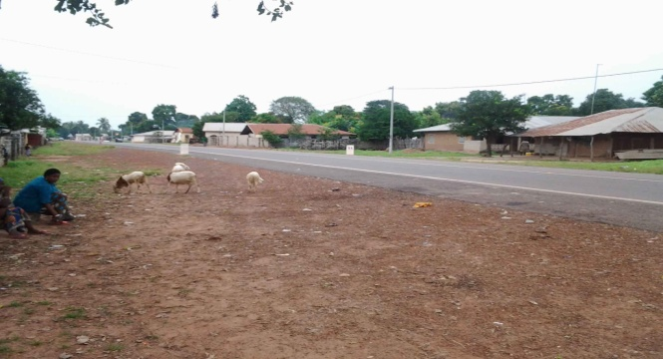
I was on the ferry in October going across to a village called Farafenni. My visit to the village was blessed by God. I ran into a friend who is now the Principal of the Anglican Secondary School. He welcomed the idea of doing mission work in his school and the community and promised his fullest support. He also told me and others I went with that there are other villages namely Dutabullu and Yalla Ba where there is no church and those who profess faith in Christ are being isolated and sometimes mistreated. I plan to take the Gospel to these communities and when God provides, take food along for these brothers and sisters who are in the minority and are being persecuted for their faith. Remember these communities in prayer. I plan to organize an outreach for the students at the Anglican secondary School in Farafenni where I look forward to sharing the Gospel and responding to questions. Soliciting your prayers in advance for this outreach. During my visit, I also went to some Manjago communities there.
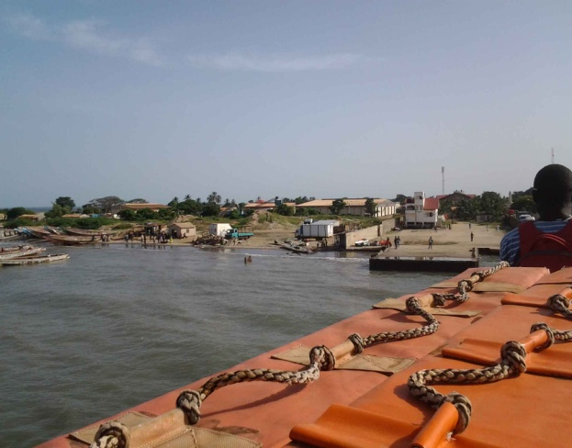
Pastor Sylvester Konteh invited me to Brikama to give a case for Jesus Christ from the Old and New Testament. The meeting was blessed by God with so many amazing testimonies. Even the Muslims who were present told me that even though they’ve never considered Jesus Christ as revealed in Scripture, they learnt so many new things from my talk. Many questions were asked to which I responded. A Christian elder told everybody that this is what they need in Brikama. He lamented that many youths have gone astray because they didn’t really know what they believe. The community looks forward to such outreach in the future. Pray for all who were present that my case for Christ will be given a verdict; pray that they will all come to bow the knee to Christ as Lord.
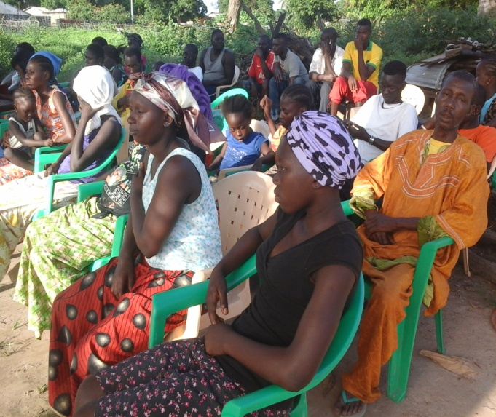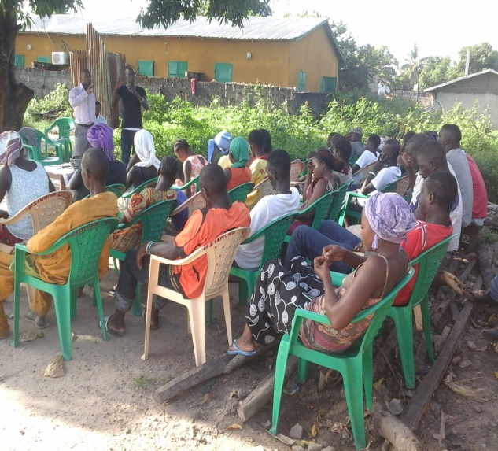
Our Bible class in Kabekel village has been progressing and we are learning new things every class about the person and work of Christ. Pray for these young people who are mostly Roman Catholic, that they will come to know the truth and share it to others around them. Like the old dad in Darsilami village told me, the problem with most professing Christians is the lack of knowledge. With God help, I want to use my missionary zeal to help these youth know what they believe and why they believe it. I know God can use them for a massive revival in not just Kabekel but the Gambia as a whole.
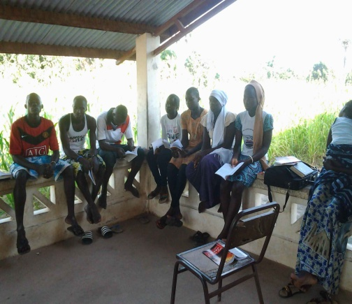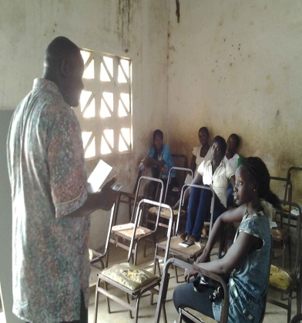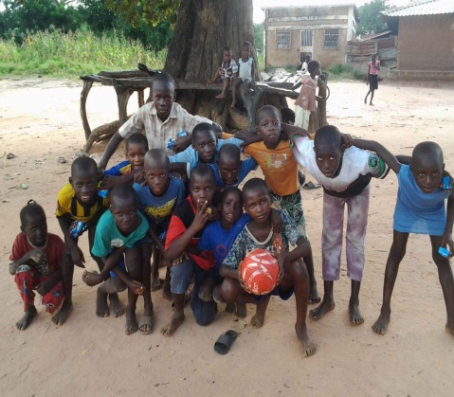
The Pastors fellowship has been going on successfully. We recently received copies of Dabney’s Systematic theology books from the Banner of truth trust. Every pastor got a copy and they send their appreciation and prayers. Some of the pastors requested that we pray for the givers of the gifts before we left the class which we did. I have been giving out copies of different articles for their personal reading. It’s really hard to get many pastors committed to a program but by God’s doing we’ve had a good turn-out so far. They are looking forward to receiving our friends from Scotland in November during which we will be having a seminar with pastors and church leaders. Pray for the pastors that God will use the lectures on ‘Reformed Experiential Preaching’ as a tool for doctrinal, experiential and practical Bible based ministry work in the Gambia. Most of them I have talked to about the classes have told me the teachings have been very helpful to their work.
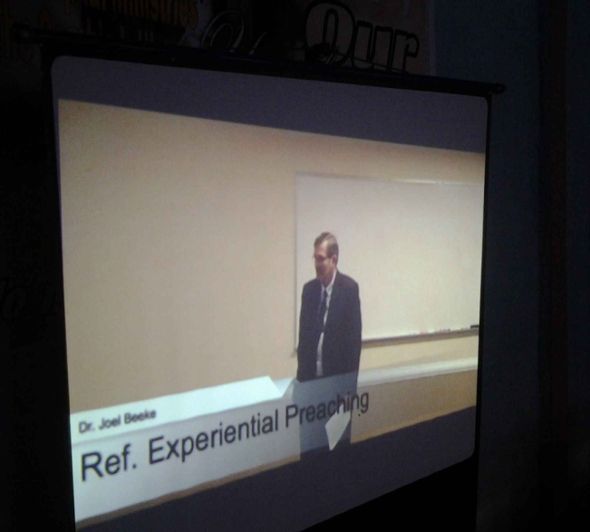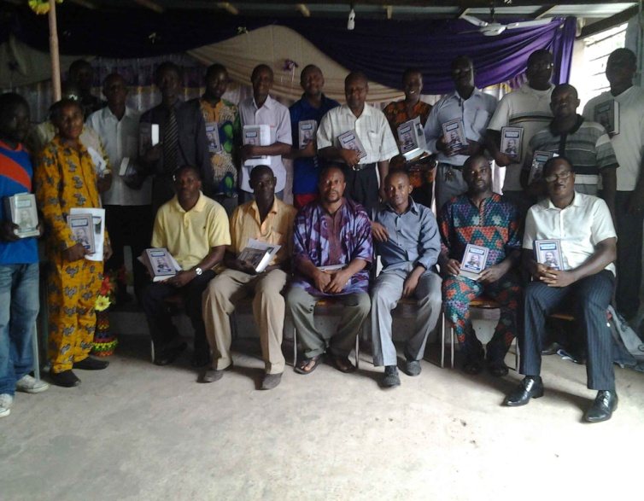Our Tuesday Bible classes have also been going on successfully and those who have consistently attended have given testimonies of how the teachings have blessed them. A Pastor’s wife talking about the class told me that “When we were coming to the Gambia, we thought we were only coming to teach the Good news of Christ but it turned out that we actually came to learn”.
A colleague at a school where I once taught once asked me “How come these things are hardly being taught in churches here?”. By ‘these things’ he meant the things he has been learning from the class. One of the Pastors who was once an opposition to some of the things taught in the class says God used the teaching to bring him to an awareness of his errors and embrace biblical truth. He has ever been a great help to me in missions and has been reading book after book from our collection here. Pray that the teachings be blessed to both believer and unbeliever causing the renewing of mind and leading to faith in Christ respectively.
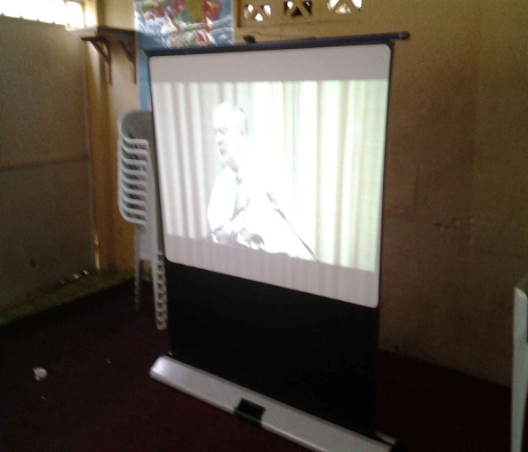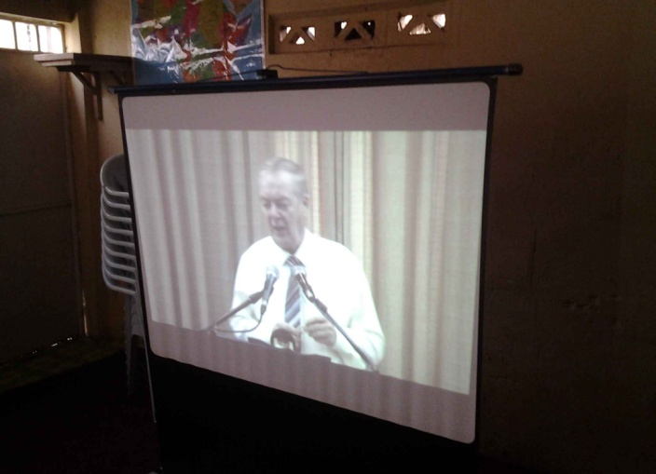
The work in the Gambia has not been without challenges but in all things I give God the glory. Continue to pray for the Gambia especially those to whom God leads us. Pray that the eyes of their hearts may be enlightened, so that they may know what the hope of his calling is. Pray that the word of God will spread rapidly and be glorified (cf Ephesians 1:18,2 Thessalonians 3:1).

“Brethren, pray for us” (2 Thessalonians 5:25)

“People who do not know the Lord ask why in the world we waste our lives as missionaries. They forget that they too are expending their lives…and when the bubble has burst, they will have nothing of eternal significance to show for the years they have wasted”- Nate Saint, missionary martyr

“ ‘Not called’! Did you say?
‘Not heard the call’, I think you should say.
Put your ear down to the Bible, and hear him bid you go and pull sinners out of the fire of sin. Put your ear down to the burdened, agonized heart of humanity, and listen to its pitiful wail for help. Go stand by the gates of hell and hear the damned entreat you to go to their father’s house and bid their brothers and sisters and servants and masters not to come here. Then look Christ in the face-whose mercy you have professed to obey- and tell him whether you will join heart and soul and body and circumstances in the march to publish his mercy to the world” - William Booth

Yours in His Service,
Philip A. Senessie

